# Intro to NLP 2022: Assignment 1

In this assignment, we work with a dataset that contains sentences from news articles. It has been collected for a shared task at SemEval 2018 for *Complex Word Identification*.

**Task Description:** <https://sites.google.com/view/cwisharedtask2018/>

**Code for the assignment:** ​​*intro2nlp_assignment1_code.zip*

You submit a **pdf** of this document, the format should not be changed.

All floating point numbers should be rounded to **two decimals**.

Your analyses should be conducted using **python 3.8**.   
You submit a **zip**-file containing all your code.

You are allowed to use Python packages (e.g. pandas, sklearn).

Each team member needs to be able to explain the details of the submission. By default, all team members will receive the same grade. If this seems unjust to you, provide an extra statement indicating the workload of each team member.

**Total points**: 20

**Structure:**

* Part A: Linguistic analysis of the dataset using spacy, 6 points
* Part B: Understanding the task of complex word identification, 7 points
* Part C: Modeling the task with an LSTM, 7 points
* Bonus tasks: options for obtaining a grade >8

Fill in your details below:

**Group number: 17**

**Student 1**

**Name: Gergő Pandurcsek**

**Student id: 2730356**

**Student 2**

**Name:**

**Student id:**

**Student 3**

**Name:**

**Student id:**

## PART A: Linguistic analysis using spaCy

In the first part of the assignment, we focus on an analysis of the sentences in the training data.

**File:** *data/preprocessed/train/sentences.txt*

Implement your analyses in *TODO_analyses.py.*

Note that we are using the most recent spaCy version (3.2) and the model *en_core_web_sm*. Results might vary for other versions. If you cannot use 3.2, clearly explain this to your TA and specify on your submission which version you are using instead.

1. **Tokenization** (1 point)  
   Process the dataset using the spaCy package and extract the following information:

Number of tokens: 15477

Number of types: 3721

Number of words: 13242

Average number of words per sentence: 18.89

Average word length: 6.54

Provide the definition that you used to determine words:

Every token that does not fall under the *punct* or *space* POS category.

(Speech and Language Processing and Essentials of Linguistics support this for this task)

1. **Word Classes** (1.5 points)

Run the default part-of-speech tagger on the dataset and identify the ten most frequent POS tags. Complete the table below for these ten tags (the tagger in the model *en_core_web_sm* is trained on the PENN Treebank tagset).

|  |  |  |  |  |  |
| --- | --- | --- | --- | --- | --- |
| Finegrained POS-tag | Universal POS-Tag | Occurrences | Relative Tag Frequency (%) | 3 most frequent tokens with this tag | Example for an infrequent token with this tag |
| NN | Noun | 2099 | 0.14 | \\, year, report | deterioration |
| NNP | Propn | 2017 | 0.13 | \, US, President | Álvarez |
| IN | Adp | 1600 | 0.1 | of, in, on, | underneath |
| DT | Det | 1313 | 0.08 | the, a, The, | An |
| JJ | Adj | 869 | 0.05 | other, Russian, military | regional |
| NNS | Noun | 779 | 0.05 | ants, police, troops | concentrations |
| , | Punct | 699 | 0.05 | … | … |
| . | Punct | 655 | 0.04 | . ? ! | ! |
| VBN | Verb | 454 | 0.03 | accused, known, killed | hospitalised |
| VBD | Verb | 451 | 0.03 | said, reported, told | plated |

1. **N-Grams** (1.5 points)  
   Calculate the distribution of n-grams and provide the 3 most frequent

Token bigrams: \\ " : 240, of the : 82, , and : 67

Token trigrams: , \\ " : 40, \\ " . : 28, \\ " , : 13

Fine-grained POS bigrams: DT NN: 671, NNP NNP: 608, IN DT: 586

Fine-grained POS trigrams: IN DT NN: 292, NNP NNP NNP: 200, DT NN IN: 195

Universal POS bigrams: DET NOUN: 780, NOUN PUNCT: 780, NOUN ADP: 710

Universal POS trigrams: ADP DET NOUN: 302, NOUN ADP DET: 243, VERB DET NOUN: 228

1. **Lemmatization** (1 point)

Provide an example for a lemma that occurs in more than two inflections in the dataset.

Lemma: fall

Inflected Forms: falling, fell, falls, fallen

Example sentences for each form:

* falling: The nonfatal accident left an elderly motorcyclist with broken ribs after he came off his bike avoiding the 170 tonnes of falling debris .
* fell: Bianchi 's helmet became wedged underneath the tractor , causing a diffuse axonal injury , and he fell into a coma .
* falls: The final decision on lifting Presidential immunity now falls to Congress .
* fallen: At 9 P.M. EST , INDYCAR released a statement , announcing that Wilson had suffered a severe head injury , was in critical condition and had fallen into a coma .

1. **Named Entity Recognition** (1 point)

Number of named entities: 1614  
Number of different entity labels: 17

Analyze the named entities in the first five sentences. Are they identified correctly? If not, explain your answer and propose a better decision.

2nd sentence : ROS not a named entity, no entities in this sentence.

5th sentence : \ not a named entity

## PART B: Understanding the task of complex word identification

1. **Explore the dataset** (1.5 points)  
   Read the documentation (<https://sites.google.com/view/cwisharedtask2018/datasets>) of the dataset and provide an answer to the following questions:

a) What do the start and offset values refer to? Provide an example.

The start offset is the number from which character the target word (/sequence) starts.

The end offset is the number at which character the target word (/sequence) ends.

Both China and the Philippines flexed their muscles on Wednesday. 31 51 flexed their muscles

Starting from B, the 31st character is the f of the flexed word which is part of the target word and the 51st character is after the s of muscles, which is the last part of the target word

b) What does it mean if a target word has a probabilistic label of 0.4?

Both China and the Philippines flexed their muscles on Wednesday. 31 37 flexed 10 10 2 6 1 0.4

# of natives who read the sentence : 10

# of non-natives who read the sentence : 10

Total : 10+10=20

# of natives who marked the target word as complex : 2

# of non-natives who market the target word as complex : 6

Total : 2+6=8

Probability : 8/20 = 0.4

c) The dataset was annotated by native and non-native speakers. How do the binary and the probabilistic complexity label account for this distinction?

None of them makes distinction between the annotators, the binary value is flipped by any marking, and the probability uses cumulative values.

1. **Extract basic statistics** (0.5 point)

Let’s have a closer look at the labels for this task.   
 Use the file *data/original/english/WikiNews_Train.tsv* and extract the following columns:

Target word, binary label, probabilistic label

Provide the following information:

Number of instances labeled with 0: 4530

Number of instances labeled with 1: 3216

Min, max, median, mean, and stdev of the probabilistic label:

0, 1, 0, 0.084, 0.17

Number of instances consisting of more than one token: 1086

Maximum number of tokens for an instance: 10

1. **Explore linguistic characteristics** (2 points)  
   For simplicity, we will focus on the instances which consist only of a single token and have been labeled as complex by at least one annotator.   
   Calculate the length of the tokens as the number of characters.

Calculate the frequency of the tokens using the wordfreq package (<https://pypi.org/project/wordfreq/>).

Provide the Pearson correlation of length and frequency with the probabilistic complexity label:

Pearson correlation length and complexity: 0.3

Pearson correlation frequency and complexity: -0.31

Provide 3 scatter plots with the probabilistic complexity on the y-axis.

X-axis: 1) Length 2) Frequency 3) POS tag

Set the ranges of the x and y axes meaningfully.

Plot 1:

Plot 2:

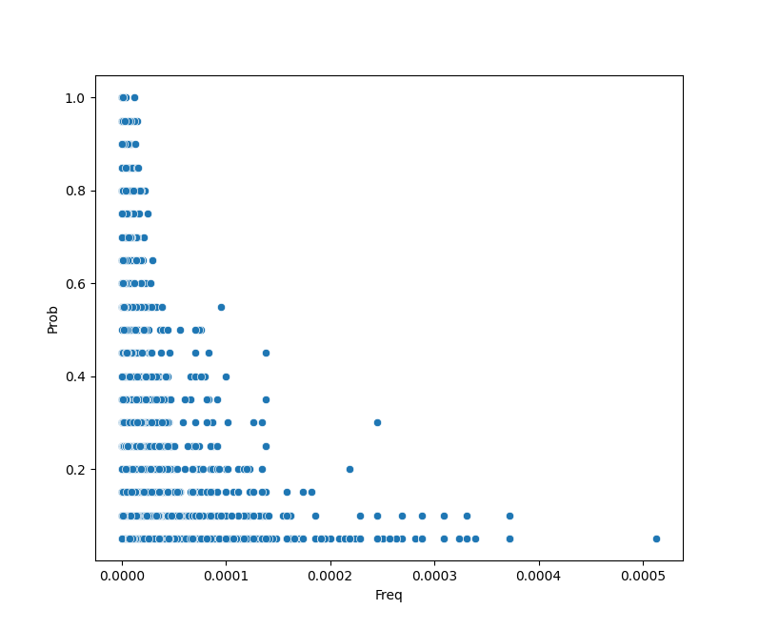

Plot 3:

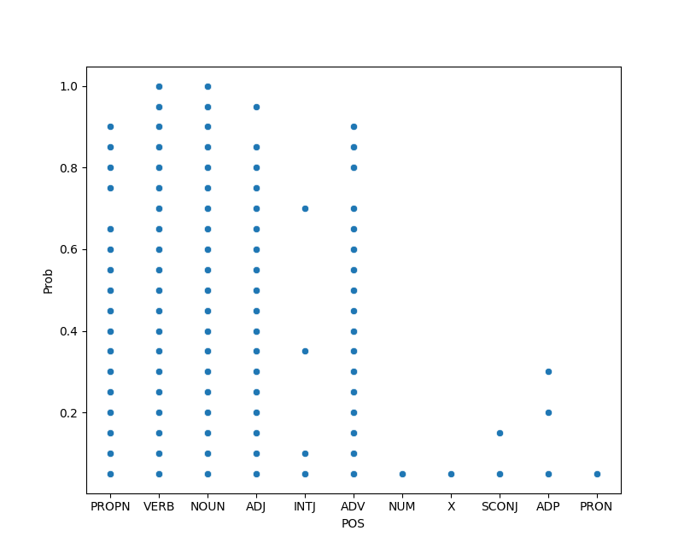

Interpret the results in 3-5 sentences:

Length – Complexity :

The plot is in line with the correlation, the words can become a lot more complex around length 5, below that there are fewer combinations of characters for a word which makes them easier to memorize and recognize.

Frequency – Complexity :

The plot is again in line with the correlation, there seems to be a negative exponential correlation between the frequency and complexity, which makes sense, since the more frequent a word is, the higher the chance that you are familiar with that word.

POS – Complexity :

We can see that not every tag is similarly complex, in my opinion the cause of this is the number of words in that particular vocabulary, there are a lot less adpositions or numbers than nouns and verbs, therefore they are easier to recognize and memorize.

1. **Reflection (1 Point)**

Can you think of another linguistic characteristic that might have an influence on the perceived complexity of a word? Propose at least one and explain your choice in 2-4 sentences.

Phonetics :

If you pronounce a word differently than it is written, it is can be harder to recognize it if you haven’t seen it in written form much before. For example: coup d'état

1. **Baselines** (2 Points)

Implement four baselines for the task in *TODO_baselines.py*.

Majority baseline: always assigns the majority class

Random baseline: randomly assigns one of the classes

Length baseline: determines the class based on a length threshold

Frequency baseline: determines the class based on a frequency threshold

Test different thresholds and choose the one which yields the highest accuracy on the dev_data:

Length threshold: 8

Frequency threshold: 0.00004

Fill in the table below (round to two decimals!):

|  |  |  |
| --- | --- | --- |
| Baseline | Accuracy on dev | Accuracy on test |
| Majority | 0.85 | 0.8 |
| Random | 0.5 | 0.5 |
| Length | 0.88 | 0.85 |
| Frequency | 0.74 | 0.76 |

Interpret the results in 2-3 sentences.

The reason why the majority baseline is so high because the classes are imbalanced, and the random baseline was generated over 100 cases which could explain the 50% accuracy. It seems like the length is a stronger predictor of complexity than frequency.

Store the predictions in a way that allows you to calculate precision, recall, and F-measure and fill the table in exercise 12.

## PART C: Modeling the task

For part C, we use an implementation for a vanilla LSTM which was originally developed for a named entity recognition project for a Stanford course. You can find more documentation here: <https://github.com/cs230-stanford/cs230-code-examples/tree/master/pytorch/nlp>

1. **Understanding the code** (1.5 Points)  
   Familiarize yourself with our version of the code and try to understand what is going on.

Answer in your own words (1-3 sentences per question)

Run the file *build_vocab.py*. What does this script do?

Inspect the file *model/net.py.* Which layers are being used and what is their function?

How could you change the loss function of the model?

1. **Detailed evaluation** (2.5 points)

Train the model on the data in *preprocessed/train* and *preprocessed/dev* by running the code in *train.py*.

Evaluate the model on the data in *preprocessed/test* by running *evaluate.py*.

The original code only outputs the accuracy and the loss of the model. I adapted the code, so that it writes the predictions to *experiments/base_model/model_output.tsv.*

Implement calculations for precision, recall, and F1 for each class in *TODO_detailed_evaluation.py*. You can use existing functions but make sure that you understand how they work.

Provide the results for the baselines and the LSTM in the table below.

|  |  |  |  |  |  |  |  |
| --- | --- | --- | --- | --- | --- | --- | --- |
| Model | Class N | | | Class C | | | Weighted Average |
|  | Precision | Recall | F1 | Precision | Recall | F1 | F1 |
| Random |  |  |  |  |  |  |  |
| Majority |  |  |  |  |  |  |  |
| Length |  |  |  |  |  |  |  |
| Frequency |  |  |  |  |  |  |  |
| LSTM |  |  |  |  |  |  |  |

1. **Interpretation** (1.5 Points)

Compare the performance to the results in the shared task (<https://aclanthology.org/W18-0507.pdf>) and interpret the results in 3-5 sentences. Don’t forget to check the number of instances in the training and test data and integrate this into your reflection.

1. **Experiments** (2 points)  
   Vary a hyperparameter of your choice and plot the F1-results (weighted average) for at least 5 different values. Examples for hyperparameters are embedding size, learning rate, number of epochs, random seed,

Hyperparameter:

Plot:

Interpret the result (2-4 sentences):

Provide 3 examples for which the label changes when the hyperparameter changes:

1. Example 1, Label at Value 1, Label at Value 2
2. Example 2, Label at Value 1, Label at Value 2
3. Example 3, Label at Value 1, Label at Value 2

## Bonus Tasks

The maximum grade you can get for the assignment is an 8. If you want to obtain a better grade, you need to individually send results for one of the bonus tasks to intro2nlp@googlegroups.com. If the group project grade is less than an 8, we do not check the bonus task submission. If the group project grade is an 8 and you submitted an answer for a bonus task, you might still only receive an 8, if the quality of the bonus task submission is not sufficient.

Task options:

* Provide answers for exercises 8 and 12-14 for at least one of the other languages of the CWI task.
* Improve the model by making a substantial change. Varying a hyperparameter or simply adding another layer **is not** a substantial change. Motivate your modification and interpret the findings.
* Identifying complex words is only the first step for lexical simplification. Read up on related work and explain potential architectures for contextualized lexical simplification in detail.